**CP Club 365 Days Challenge**

**Programming language – Any language**

**Problem Statement**

<https://www.codechef.com/problems/EVENTUAL>

<https://www.codechef.com/viewsolution/86582259>

**Your Code**:

# cook your dish here

# cook your code here

a=int(input())

for i in range(a):

b=int(input())

d=input()

c=0

for i in d:

c=d.count(i)

if(c%2==0):

c=0

else:

c=1

break

if(c!=0):

print("NO")

else:

print("YES")

**Output (Screen Shot)**:

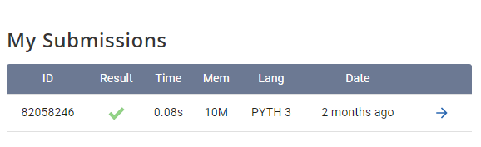

**Understanding about problem:**

In this problem string is given of some length n and we have to select substring of string such that each char occurs even number of times. After that we need to remove the substring from that string. In that substring also we need to choose that the elements are occurring even times. We can either create map or frequency array and count the number of occurrence of elements and if it is even then print yes or else no.

Note: If you can't understand the problem, feel free to contact us and we'll help you. Please don't copy and paste from anywhere.

ALL THE BEST

Team CP Club